**PIZZA SALES SQL QUERIES**

**1.Total revenue:**

select SUM(total_price) as total_revenue from pizza_sales;



**2.Total pizza sold**

select SUM(quantity) as Total_pizza_sold from pizza_sales;



**3.  Average order value**

select SUM(total_price) / COUNT(DISTINCT order_id) as avg_ord_val from pizza_sales;



**4.total order**

select count(DISTINCT order_id) as total_order from pizza_sales;



**5. avg_pizza_per_order**

select cast(sum(quantity) as decimal (12,2))/cast(count(distinct order_id) as decimal (12 , 2)) as avg_pizza_per_order from pizza_sales;



**6.daily trend for total order**

select DATENAME(DW , order_date) as Days ,sum(distinct order_id) as Total_revenue

from pizza_sales

group by DATENAME(DW , order_date);

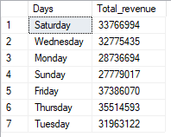

**7.monthly trend for total order**

select DATENAME(MONTH , order_date) as months ,sum(distinct order_id) as total_revenue

from pizza_sales

group by DATENAME(MONTH , order_date);

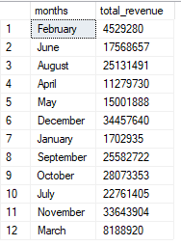

**8.percentage of sales by pizza category**

select pizza_category , sum(total_price) as total_price , sum(total_price)*100 / (select sum(total_price) from pizza_sales) as per_sales

from pizza_sales

group by pizza_category;

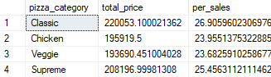

Note :if we want to filter based on month , week , quarter then use where clause . for ex

select pizza_category , sum(total_price) as total_price , sum(total_price)*100 / (select sum(total_price) from pizza_sales) as per_sales

from pizza_sales

where MONTH (order_date) = 4 # 4 means April data

group by pizza_category;

above code shows only percentage of April month out off all the month

select pizza_category , sum(total_price) as total_price , sum(total_price)*100 / (select sum(total_price) from pizza_sales where MONTH (order_date) = 4) as per_sales

from pizza_sales

where MONTH (order_date) = 4

group by pizza_category;

above code shows percentage of April month

also we can round off percentage using cast

select pizza_category , cast(sum(total_price) as decimal(12,2)) as total_price , cast(sum(total_price)*100 /(select sum(total_price) from pizza_sales where MONTH (order_date) = 4) as decimal (12 , 2)) as per_sales

from pizza_sales

where MONTH (order_date) = 4

group by pizza_category;

9. **% of Sales by Pizza Size**

select pizza_size , sum(total_price) *100 / (select sum(total_price) from pizza_sales) as percentg

from pizza_sales

group by pizza_size;

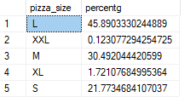

10. **Total Pizzas Sold by Pizza Category**

select pizza_category ,sum(quantity) as Total_quantity

from pizza_sales

group by pizza_category

order by Total_quantity DESC;

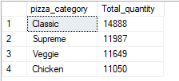

11.top 5 pizza by revenue

select TOP 5 pizza_name , sum(total_price) as total_revenue

from pizza_sales

group by pizza_name

order by total_revenue desc;

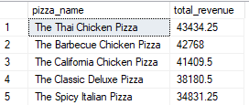

12.top 5 pizza by quantity

select top 5 pizza_name , sum(quantity) as Total_quantity

from pizza_sales

group by pizza_name

order by Total_quantity DESC;

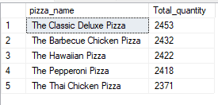

13.top 5 pizza by total_order

select top 5 pizza_name , count(distinct order_id) as total_order

from pizza_sales

group by pizza_name

order by total_order desc;

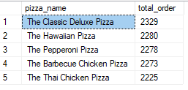

12.Bottom 5 pizza by revenue

select top 5 pizza_name , sum(total_price) as total_price

from pizza_sales

group by pizza_name

order by total_price ASC;

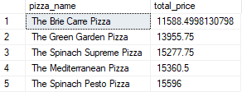

13.Bottom 5 pizza by quantity

select top 5 pizza_name , sum(quantity) as total_quantity

from pizza_sales

group by pizza_name

order by total_quantity ASC;

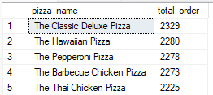

14.Botom 5 pizza by total_order

select top 5 pizza_name , count(distinct order_id) as total_order

from pizza_sales

group by pizza_name

order by total_order ASC;

